SOLUTIONS

Module: | 3D Graphics Programming Tools
Module Code | EBU7405 | Paper | B
Time allowed | 2hrs | Filename | Solutions_2021_EBU7405_B
Rubric | Answer ALL FOUR questions
Examiners | Dr Marie-Luce Bourguet | Dr Pengwei Hao

Question 1
a) For each OpenGL function below, state if it is a “primitive generating” function or a “state changing” function. Justify your answers.
[8 marks]
- glOrtho
(3 marks)
Solution: state changing (1 mark). This function is used for projection transformations (1 mark) and affects the PROJECTION matrix, which belongs to the state (1 mark).
ii) glScale
(2 marks)
Solution: state changing (1 mark). This function is used for modelling transformations and affects the MODELVIEW matrix, which belongs to the state (1 mark).
- glVertex
(3 marks)
Solution: primitive generating (1 mark). The glVertex function is used to declare 2D or 3D points (1 mark) which are the elementary geometric primitives of 3D models (1 mark).

b) Consider the code shown in Code Box 1 on the next page.
[11 marks]
- Briefly describe what appears on screen when executing this code.
(2 marks)
Solution: This code creates a rotating (1 mark) square figure. (1 mark)

- Select four statements in this code that contribute to the creation of a smooth animation and explain their respective purpose.
(8 marks)
Solution :
glutInitDisplayMode (GLUT_DOUBLE | GLUT_RGB); (1 mark)
This statement requests double buffering (front and back buffers) to guarantee smooth animation (0.5 mark). Double buffering is used to avoid writing and reading the colour buffer simultaneously (0.5 mark).
glutIdleFunc (spinDisplay); (1 mark)
This statement declares an idle callback function which will be triggered once for every event loop if there are no other events to be handled. (0.5 mark). The idle callback function (spinDisplay) is then used to update the back buffer and create the animation (0.5 mark).
glutPostRedisplay(); (1 mark)
This statement requests that the display callback be executed after the idle callback returns (0.5 mark), making sure the window gets redrawn at most once each time the GLUT goes through the event loop (0.5 marks)
glutSwapBuffers (); (1 mark)
This statement swaps the front and back buffers when using double buffering for animations (0.5 marks). It replaces the glFlush() command. (0.5 mark)

- Modify one line in the code to make the animation go faster.
(1 mark)
Solution: spin = spin + 10.0; or any value above 5.0 and below 180.0 (1 mark)

c) This question is about the OpenGL camera.
[6 marks]
- What are the properties of the default OpenGL camera?
(3 marks)
Solution: centered at the origin (1 mark), oriented towards the negative Z axis (1 mark), orthographic lens with viewing volume of size 2 (1 mark).

- Write the arguments of the glOrtho function that correspond to the default camera.
(3 marks)
Solution: glOrtho (-1.0, 1.0, -1.0, 1.0, -1.0, 1.0); (1 mark for each (-1,1) pair, up to 3 marks).

#include <GL/glut.h>
#include <math.h>

#define DEGREES_TO_RADIANS 3.14159/180.0

static GLfloat spin = 0.0;
GLfloat a, b;

void square()
{
glBegin(GL_QUADS);
glVertex2f(a , b);
glVertex2f(-b , a);
glVertex2f(-a , -b);
glVertex2f(b , -a);
glEnd();
}

void display()
{
glClear (GL_COLOR_BUFFER_BIT);
square();
glutSwapBuffers ();
}

void spinDisplay (void)
{
spin = spin + 5.0;
if (spin > 360.0) spin = spin - 360.0;
a = 0.5 * cos(DEGREES_TO_RADIANS * spin);
b = 0.5 * sin(DEGREES_TO_RADIANS * spin);
glutPostRedisplay();
}

int main(int argc, char** argv)
{
glutInit(&argc,argv);
glutInitDisplayMode (GLUT_DOUBLE | GLUT_RGB);
glutInitWindowPosition(500,0);
glutCreateWindow("double buffered");
glutDisplayFunc(display);
glutIdleFunc (spinDisplay);
glutMainLoop();
}

Code box 1

Question 2
a) This question is about modelling.
[5 marks]
- Name three classes of methods for geometric modelling.
(3 marks)
Solution:
Point-based, Surface-based, Constructive methods (each for 1 mark)
(1 mark for each, total 3 marks)

ii) Name four file formats for 3D models.
(2 marks)
Solution:
any 4 of these: STL, OBJ, FBX, COLLADA, VRML and X3D
(0.5 mark for each, total 2 marks)
b) This question is about geometric transformations.
[11 marks]
- Consider Model A and Model B in Figure 1. Give a chain of the basic transformation matrices for translation, scaling and rotation which, when post-multiplied by the homogeneous coordinates of the vertices of Model A, will transform the vertices of Model A into their corresponding vertices of Model B, such that the vertex at 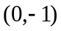 of Model A is transformed to the vertex at 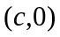 of Model B.
(7 marks)
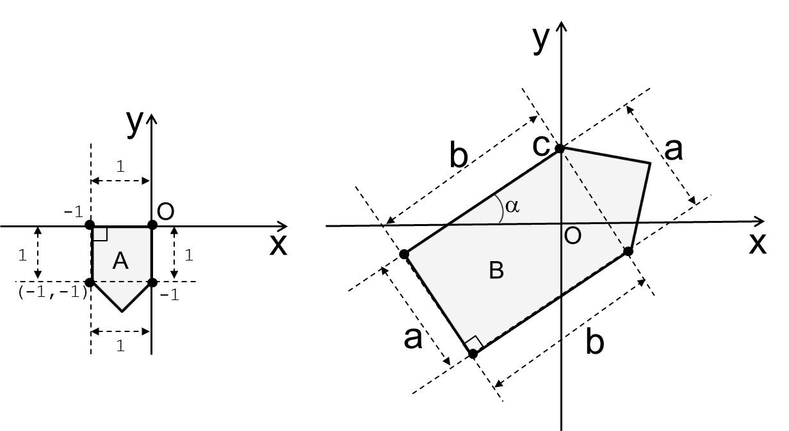
(Model A) (Model B)
Figure 1.

Solution:
The matrices can be 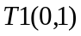 for translation, 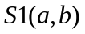 for scaling, 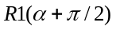 for rotation , and 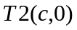 for translation: (2 marks)
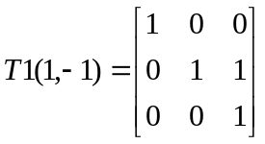 (1 mark)
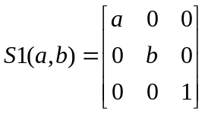 (1 mark)
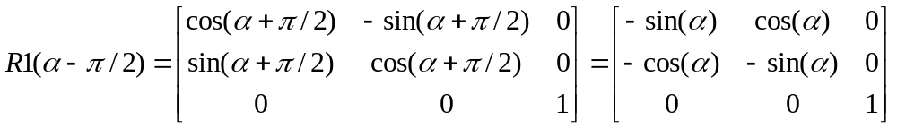 (2 marks)
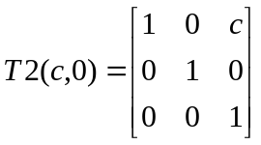 (1 mark)
[Total 7 marks]

ii) Compute the composite 2D transformation matrix for the transformations found in question i) above.
(4 marks)

Solution:
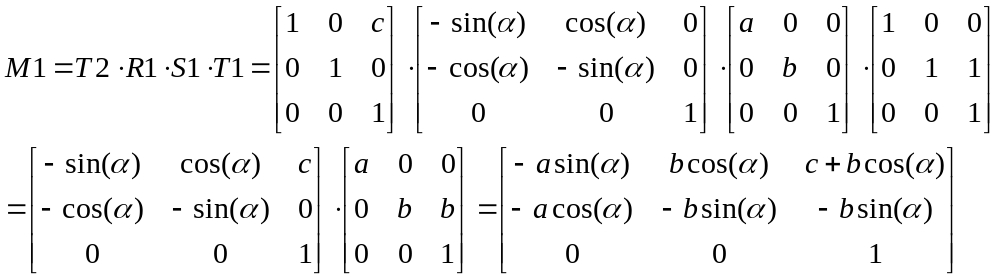
(1 mark for each step, total 4 marks)

c) Write the OpenGL functions that correspond to the three transformations illustrated in Figure 2. Estimate their parameters.
[6 marks]

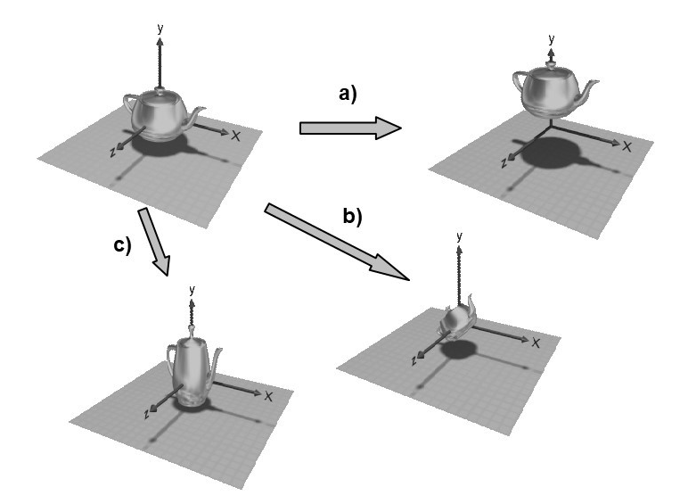
Figure 1

Solution: a) glTranslated (0.0, 10.0, 0.0) (1 mark for the function, 1 mark for valid parameters, i.e. only y is non zero)
b) glRotated (45.0, 0.0, 0.0, 1.0) (1 mark for the function, 1 mark for valid parameters)
c) glScaled (0.6, 2.0, 0.6) (1 mark for the function, 1 mark for valid parameters)

d) What information do we need to consider for a lighting model?
[3 marks]
Solution:
Emission at light sources
Scattering at surfaces
Reception at the camera
(1 mark for each, total 3 marks)

Question 3
a) This question is about lighting calculations in OpenGL. Describe the appearance (colour and shininess) of an object illuminated under the conditions declared in Code box 2.
[6 marks]

float light_ambient[] = {1.0, 0.5, 0.5, 1.0};
float light_diffuse[] = {0.0, 1.0, 0.0, 1.0};
float light_specular[] = {1.0, 1.0, 1.0, 1.0};
float material_ambient[] = {0.8, 0.3, 0.3, 1.0};
float material_diffuse[] = {0.0, 0.4, 0.0, 1.0};
float material_specular[] = {1.0, 1.0, 1.0, 1.0};
float shininess = 10.0;

Code box 2

Solution: The ambient light component is pink (1 mark), which the object will reflect according to its material_ambient components: (1.0*0.8, 0.5*0.3, 0.5*0.3) = (0.8, 0.15, 0.15) (1 mark). The ambient reflection is a fairly bright and unsaturated red, i.e. pink. (1 mark)
Diffuse calculations: (0.0 * 0.0, 1.0 * 0.4, 0.0 * 0.0) = (0.0, 0.4, 0.0), which is a fully saturated but not very bright green (1 mark).
Specular component: the shininess is set to 10, so there will be a large highlight, which will be white (1 mark).
Overall, the faces directly illuminated by the light source will appear shiny and the colour will be: (0.8+0.0, 0.15+0.4, 0.15+0.0) = (0.8, 0.45, 0.15) which is a kind of orange (1 mark).

b) Referring to the similarities between WebGL and OpenGL, briefly explain the role of each of the following four WebGL application elements: (1) the canvas; (2) the WebGL context; (3) the (Vertex Buffer Object); and (4) the IBO (Index Buffer Object).
[9 marks]

Solution: The canvas is an HTML5 element (1 mark), which acts as the viewport (window) or drawing space (1 mark).
The WebGL context is used to access the WebGL API (1 mark), it acts like a state machine (1 mark).
The VBO is the Vertex Buffer Object (1 mark), similar to the list of vertex coordinates in OpenGL (1 mark).
The IBO is the Index Buffer Object (1 mark), it indicates how to use the VBO (1 mark), similar to the list of faces in OpenGL (1 mark).

c) This question is about 3D modelling types and tools.
[10 marks]
- What are the differences between solid and wireframe modelling?
(4 marks)
Solution: Solid modeling works with 3D primitive shapes, such as spheres and cubes (1 mark), which act like building blocks (1 mark). Wireframe (Polygons) are made up of straight edges (1 mark), and used to model by approximation any surface (1 mark).

ii) What are NURBS?
(3 marks)
Solution: NURBS are mathematical models (1 mark) for generating and representing curves and surfaces (1 mark). They can handle both analytic (i.e. surfaces defined by common mathematical formulae) and modeled shapes (1 mark).

iii) In Blender, would you model a cube using solid, wireframe or NURBS? Justify your answer.
(3 marks)
Solution: solid (1 mark) or wireframe (1 mark). NURBS are for curved surfaces (1 mark).

Question 4
a) This question is about projection.
[16 marks]
- Give the transformation matrix for a 2D window-to-viewport transformation. Use the variables given in Figure 3.
(5 marks)
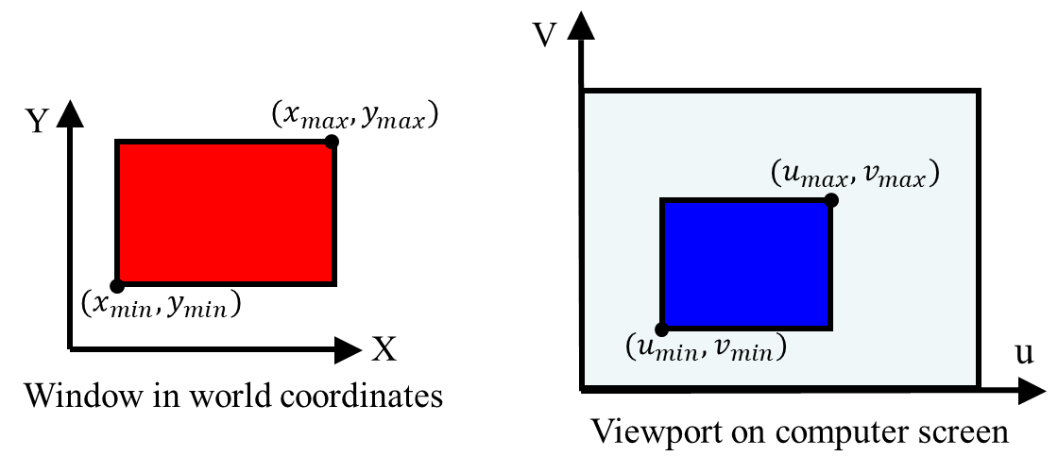
Figure 3.

Solution:
It is done by translation 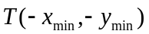, , scaling 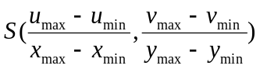, and translation 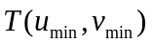. (1 mark)
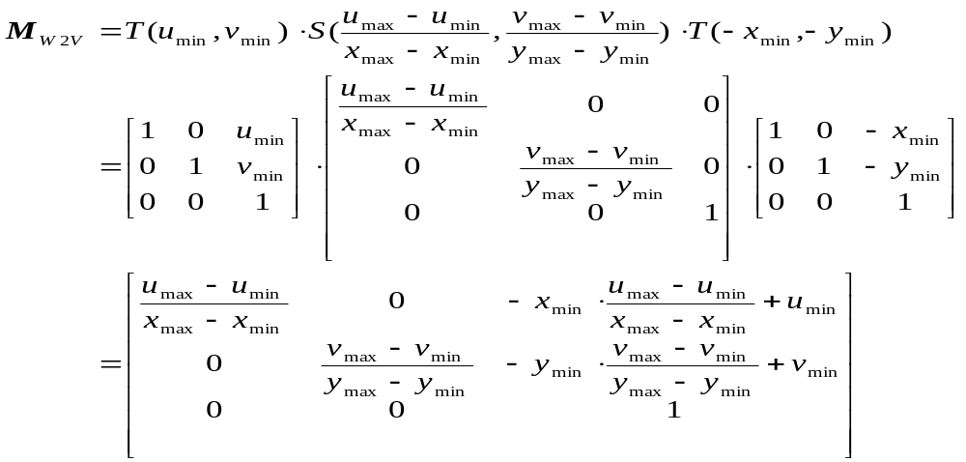
(1 mark for each matrix, 1 mark for the result matrix, total 4 marks)

- In the world coordinate system, if the view plane normal is [2,2,1], the view-up vector is [0,1,1], the view reference point is [5,6,7], and the distance from the centre of projection to the view plane is 5, find the transformation matrix for perspective projection.
(11 marks)
Solution:
The translation matrix to the view reference point:
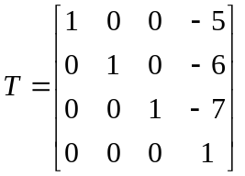 (1 mark)
The 3 axis vectors are (1 mark for n, 2 marks for u and 2 marks for v)
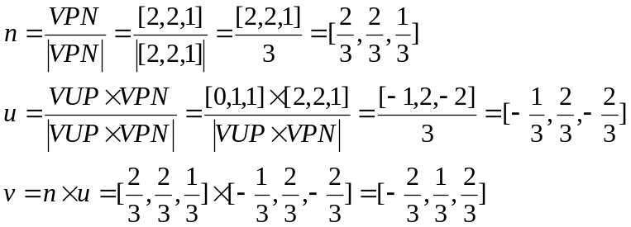
The rotation matrix is
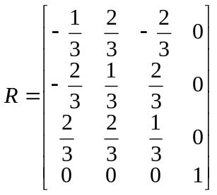 (2 marks)
The perspective projection
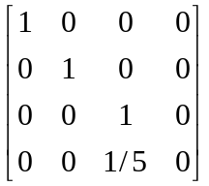 (1 mark)
The composite transformation matrix is
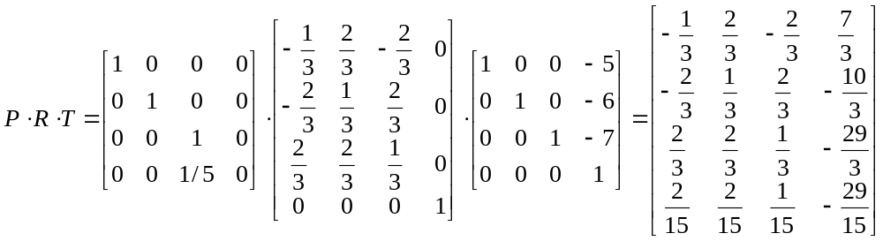 (2 marks)

(total 11 marks)

b) This question is about rasterisation.
[9 marks]
- For a line from (x0, y0) to (x1, y1), give the implicit function as the line equation F(x,y)=0. Give the normal vector of the line and show which half-plane makes F(x,y)>0 and which half-plane makes F(x,y)<0.
(5 marks)
Solution:
F(x,y) = (y1 – y0)(x – x0) – (x1 – x0)(y – y0) (2 marks)
The normal vector of the line is [(y1 – y0), –(x1 – x0)]. (1 mark)
In the normal vector positive side is positive: dot product of the normal vector and the vector from a point on the line to a point in the half-plane, F(x,y)>0. (1 mark)
In the normal vector negative side is negative: dot product of the normal vector and the vector from a point on the line to a point in the half-plane, F(x,y)<0. (1 mark)
(total 5 marks)

ii) Give a method to test if a point is inside or outside a triangle.
(4 marks)
Solution:
3 steps:
Put the vertices in a right order such that the inside is always in positive (or negative) half-plane. (2 marks)
Test if the point makes the three line equations of the three edges positive (or negative). (1 mark)
If all positive (or negative), it is inside, otherwise it is outside the triangle. (1 mark)
(total 4 marks)

